“How Stuff Works”
Hope College Name ________________________
Mission College

Speaker Lab

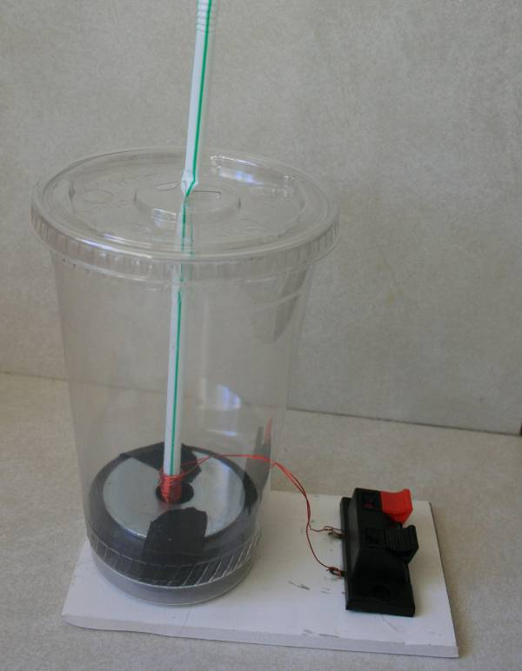

Introduction:

In this lab you will make a simple speaker with a cup, lid, straw, a permanent magnet, and magnet wire. You will observe how an electrical current is converted into a magnetic field, and how when the current and magnetic field change continuously and quickly a corresponding sound wave is produced.

Background:

Electricity and Magnetism are related. Current in a wire (moving electrons) produces a magnetic field around it. Changing current has a changing magnetic field around the wire. Current produces magnetic fields. Electricity can also be created from a changing magnetic field. By moving a magnet over a loop of wire, electricity is created.

Materials List:

20 oz. clear cup and lid
8” straw (preferably without bend or flexible/bendable joint)
4” X 5” foam core
Stereo Jacks: Dual Compression Terminals (15CT200)
One - ¼ X 2 Zinc Fender Washer
One - ½ X 2 Zinc Fender Washer
One - #10 Flat Zinc Washer
One – 10-32 Hex Nut
One – 10-32X1 Socket Head Cap Screw
Two Ceramic Ring Magnets (2.375 OD, 1.0 ID, .280T)
20 feet of 36 Gauge Magnet Wire
Six alligator clip wires
Audio Amplifier if audio source is not amplified (MP3, CD Player, Computer)
9V battery if using Audio Amp
Battery receptacle
Audio Cable or Speaker Wire depending on audio source used.
Electrical Tape

Tools:

Hot Glue Gun
Utility Knife or Sandpaper
Scissors
Solder and irons

Construction Steps:

- Put the two ceramic magnets together and set them aside. They are fragile.

- Insert the screw through the small washer and then into the 1/2 “hole of the larger washer. You are doing this so that the straw and coil will be held in the center of the ring magnets later.

- Next add the nut and finger-tighten the nut so that the screw is upright and secure. Now put the two magnets on top so that the screw is centered in the magnet’s holes. Next put the other large washer on top and center it. Optional: Tape the magnets so that the screw is in the center of the magnets’ and washers’ holes. Your magnet component should look like:

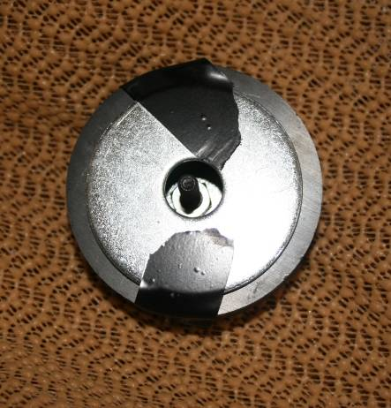

- Place the magnet-washer component into the bottom of the cup with the end of the screw facing up. The straw and coil will fit over this screw.

- Next wind the magnet wire around the end of the straw. Leave about 6” of wire free before you start to wind the wire around the end of the straw. If the straw has a bendable end, wind the magnet wire around the end that does not have the flexible joint. This wire is called a voice coil. It is OK to overlap the windings.

Leave about 6” of both wire ends free. You need an input and output for the electricity.

- Once the coil is wound around the bottom of the straw, tie one half square knot carefully to keep the wire in place. Do not yank on the wire.

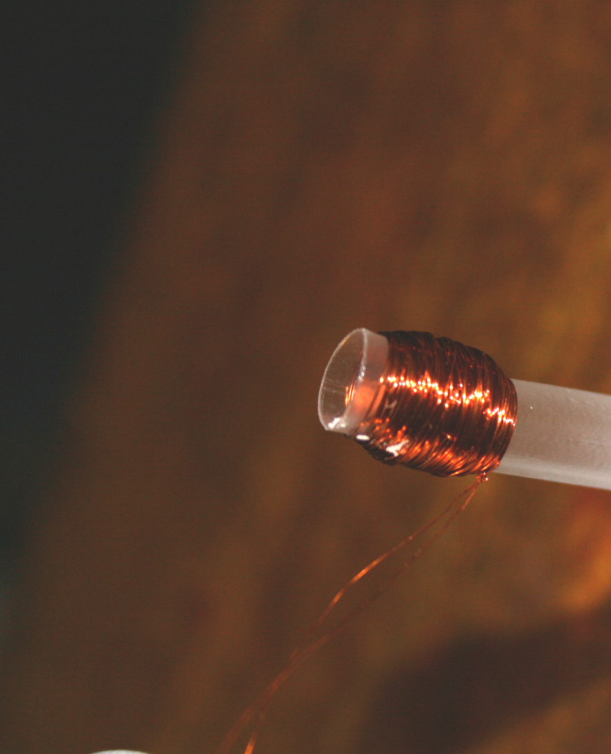

- Scrape thoroughly the ends of the coil wire with sandpaper. The red color is insulating enamel. As you scrape you will see the orange color associated with copper. You should not see any red enamel on the ends of the wire.

- Using a utility knife or scissors, carefully cut an opening in the side of the cup. The wires will come though this hole. Do not make the holes bigger than necessary.

- Gently pull both wire ends out though the hole you made in the cup.

- Insert the coil into the cup and over the screw at the bottom.

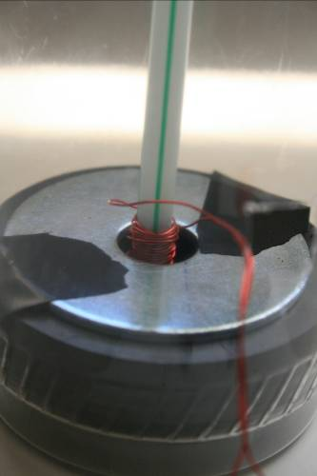

- Test your speaker. You will need an audio source and an amplifier (if audio source does not have an amp).

- Bend out the terminals on the underside of the compression terminals.

- Hot glue the cup and the compression terminals to the foam core.

- Twist, solder, or tape the ends of the coil wire to the underside of the compression terminals. Test your connection with an Ohm Meter or an audio source to ensure there is connection.

- Your speaker is complete. Test you speaker again as follows:

  - Use a stereo. Replace the speaker in your system with your homemade one. Turn up the volume and enjoy the tunes!
  - Use a non-amplified audio source. These are audio sources that you listen to with head phones or ear buds. Run this audio source through an audio amplifier before connecting the speaker.

- The objective is to get the vibrating straw to transfer all of its kinetic energy to the lid, so that the lid can act like a diaphragm and produce sound. If sound is weak, try adjusting how the straw comes in contact with the lid. Don’t allow the lid’s hole to crush the straw and do not enlarge the lid’s hole by cutting it as this will loosen the connection between the straw and the lid.

Filtering and Sound Improvements:

You may notice that base tones cause distortion in your speaker. The lid of the cup has a small diaphragm and is more suited to producing higher frequency tones. In order to produce a better base, you could insert your magnet and coil into a Tupperware-type bowl as shown. The straw should be cut and hot glued to the underside of the lid so that when the coil moves the lid moves in consort with it.

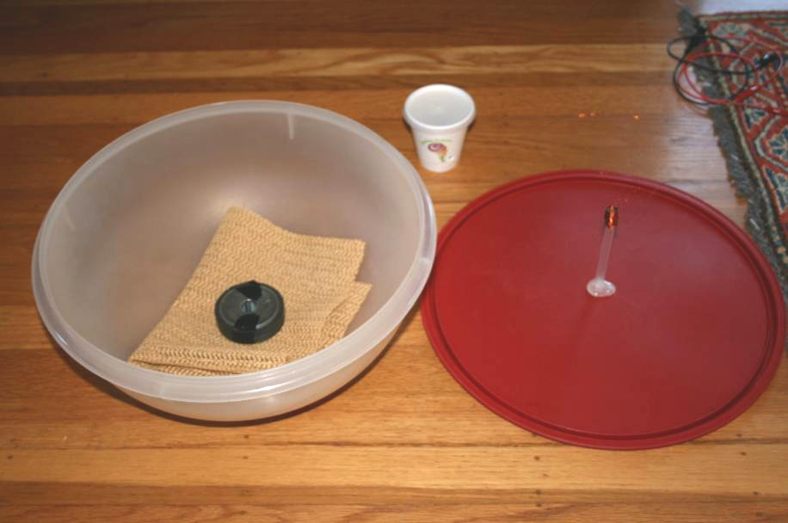

If you constructed two speakers; the original one and the large one using a round food bowl similar to the picture above, you could further improve the sound by filtering the audio before connection to the speakers.

A low-pass filter (a circuit that passes low frequency signals and blocks the high frequency signals) could be used between the audio source and the large speaker.

A high-pass filter (a circuit that passes the high frequency signals and blocks the low frequency signals) could be used between the audio source and the small speaker.

These filter circuits are referred to as a Crossover Network and are used to split and “steer” the signals to the speaker type that is best suited to produce sound in a particular frequency range.

Large speakers designed to produce base tones are called ‘woofers’. Small, dome-shaped speakers produce high frequency (treble) tones and are called ‘tweeters’.

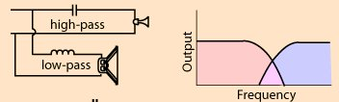
http://hyperphysics.phy-astr.gsu.edu/hbase/Audio/cross.html

The cut-off frequency for the RC high pass is: fc = 1/(2πRC)
(R of speaker is about 8Ω)
Try a cut-off of about 1000 Hz with C = 10-20 μF for the high pass.

The cut-off frequency for the RL low pass is: fc = 1/(2π) (R/L)

The cut-off frequency is the frequency where the power is ½.
Integration with Radio:

Find a partner who built the AM radio. Using the Audio Amplifier provided, test your speaker using the homemade AM radio. The amplifier should be connected after the radio’s diode.
Audio Amplifier
9 Volts
Antenna
Diode
Ground
Questions:

- What is a sound wave?

- Can sound travel through empty space? Why or why not?

- When your speaker produces sound it is because a voltage and current are applied to the coil.

  - As current flows through the coil, is a magnetic field produced around the coil?

  - Is the strength of the magnetic field constant or changing? How do you know whether the magnetic field is constant of changing?

- Explain how the coil and straw are able to vibrate. Explain how the vibration is transferred to the cup and lid?

See grading rubric below.

- Using the theory of how a speaker works, how might you build a microphone?

- What are woofers and tweeters?

Grading Rubric:

 | Response Description
0 | No attempt
1 | Answer includes an accurate description of what a speaker does (reproduces sound) rather than how it works
2 | Answer includes at least one accurate, but incomplete idea of how the sound waves are produced by the speaker
3 | Answer includes accurate explanation of how 2 or more of the following are used in a speaker: magnet, coil, vibration, sound waves, current.
4 | Answer includes accurate explanation of how 3 or more of the following are used in a speaker: magnet, coil, vibration, sound waves, current.
5 | Accurate complete explanation: The current running through the coil is an electromagnet which interacts with the permanent magnet. As the current changes the magnetic field changes in the coil. The forces between the coil and the permanent magnet change, pushing the straw up and down. As the straw moves it vibrates the cup and lid and produces a pressure wave that has the same pattern as the incoming electrical signal.

Resources:

http://micro.magnet.fsu.edu/electromag/java/faraday2/
http://www.labsanywhere.net/SlideManager/

